CLINT FOUNTAIN FURNITURE CONSERVATION
Tallahassee, FL

On Transom Boards

I am not a member of Antique Outboard Motor Club International; my son is. While I don't know as much as him about antique boats and motors, I do know a fair amount about woods and finishes. I have been with him to enough meets, and have read enough on old boat forums to know that there is a lot of discussion about what wood to use for a replacement transom boards. I even remember seeing thread on one site (I think it was tinboats.net) that was titled: “The dreaded 'What wood to use for a transom?'”

By the way, this discussion is about North American woods, not exotics from other parts of the world.

I understand that there is a lot of misinformation, old wives' tales, myths about woods to use for transom boards. I am a bit surprised that the first question was not “what woods are strong enough for transom boards?” That's perhaps as it should be; almost all North American hardwoods (and some softwoods) are strong enough to not break from the force generated by a small outboard engine. The obsession appears to center around resistance to rot. So let's talk about decay resistance first; we'll get to strength in a bit.

The wood of choice appears to be white oak. While it is true that white oak is more resistant to rot than red oaks, it is because of one feature in the wood: tyloses. Under magnification, they look like bits of saran wrap in the cells of the wood. Tyloses do slow the transfer of moisture into the cells of the wood, but they do not stop it.

This means that white oak will eventually rot, just not as fast as red oak.
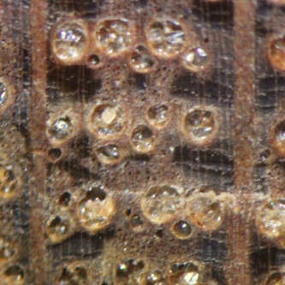

The selection of wood for a transom is not rocket science, but it is complex, with several issues to consider. If you don't think so, just pass your eye over this list of papers on wood decay from the USDA Forest Products laboratory (FPL):
https://www.fpl.fs.fed.us/search/search_action.php?phrasesAndKeywords=decay&searchmode=all&sortgroup=significance&pubyearstart=1900&pubyearend=2050&content_type=&singlebutton=

Decay:

There are a number of native American woods that are resistant to decay; they are not all hardwoods. Here is a 1961 FPL study on resistant woods:
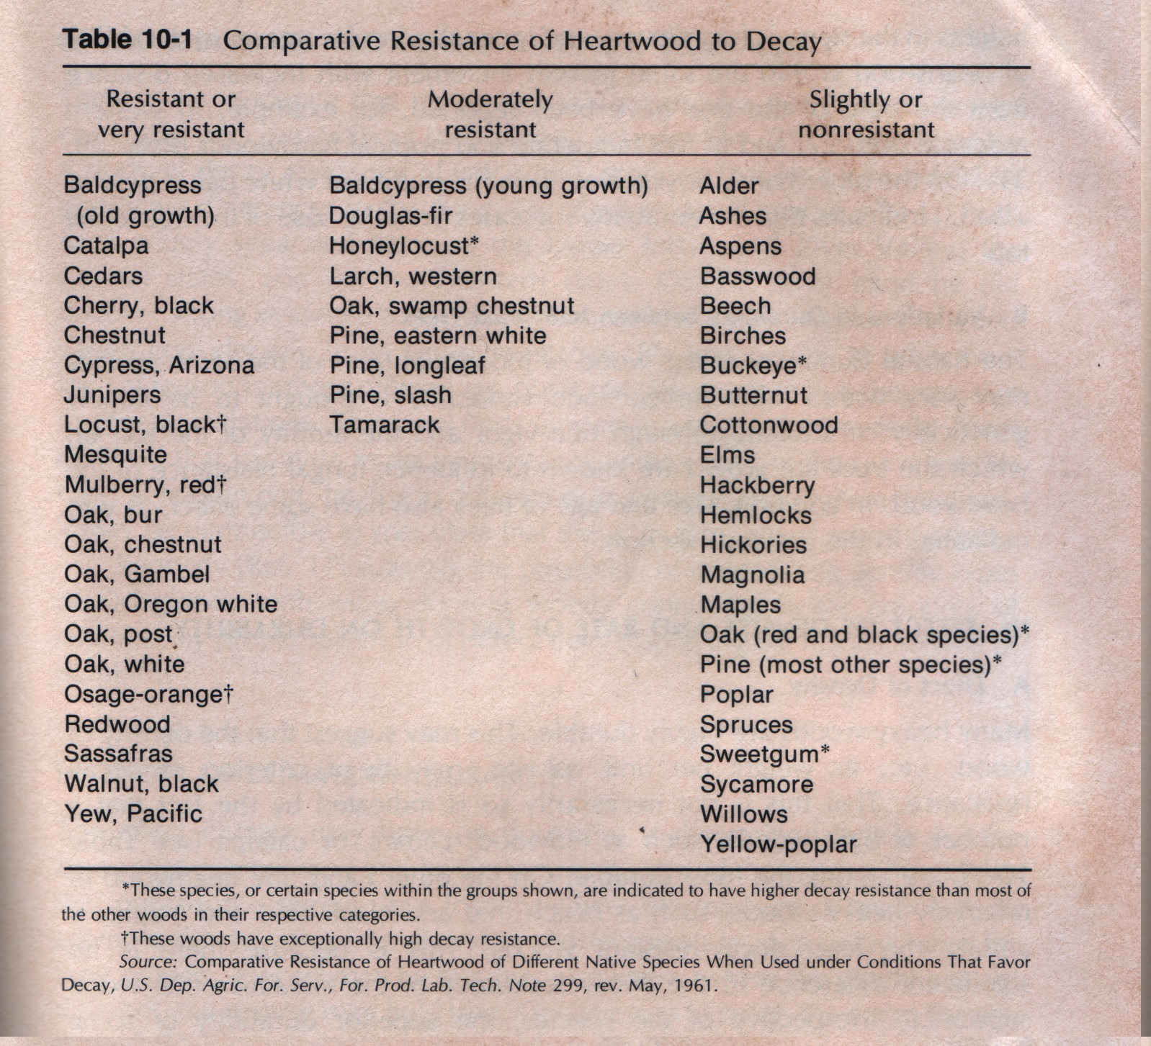
Please notice that the woods in the “most resistant” column are in alphabetical order, not by resistance. The three flagged ones are the least prone to rot. There are problems with them:

-While black locust is known being able to function as fenceposts for 25 years in the ground, you won't find any of it in sawlog size. It was mostly logged out more than 40 years ago. Notice that it is not the same as Honey Locust, a weed tree, which appears in the middle column.

-Osage-orange occurs from Texas to Virginia, but it is not frequently a large tree, is usually gnarled, and only a local sawyer might be cutting it. It also goes by the name “Bowdark”, a corruption of Bois d'Arc.

-Red mulberry is also seldom a large tree, is not commercially harvested.

It should also be noted that while old-growth cypress and white juniper are in the most resistant column, studies have shown that rot resistance can vary within the same log. And they're both soft, easily dented.

Black locust is not a pretty wood. Osage-orange and red mulberry can be; they're yellow when you saw them, become mahogany-colored as they age, and can have a pronounced chatoyance when the grain is strongly figured. But unless you go find the tree, cut it down, take it to a sawyer yourself and dry it, you are unlikely to get any lumber from either one.

Wood Technology

The “bible” on wood technology is

“Textbook of Wood Technology”, by A.J. Panshin & Carl de Zeeuw, McGraw Hill Book Company, ISBN 978-0070484405

My copy is 4th Edition, 1980. Chapter 10 is “Natural Durability of Wood; Wood Deterioration and Stains”. I couldn't find a copy online to link to; I could scan the pertinent pages, but I think it's still under copyright, so I'll summarize, and paraphrase to avoid plagiarism.

“Natural Durability of Wood; Wood Deterioration and Stains”

“Durability” means a given wood's ability to withstand attack by fungus and insects. While no untreated wood is 100% resistant, some possess a greater ability than most others. This resistance is due in part to the structure of woody cells, but is more often due to the presence of natural toxins (extractives) in the wood.

Sapwood vs Heartwood:
Sapwood is more susceptible to rot than heartwood because it doesn't contain as much or sufficiently toxic extractives as are present in the heartwood. Extractives in wood may consist of oils, tannins, or phenolics (lignin, resins). Heartwood also has a lower moisture content than sapwood; studies show that no decay can occur in wood below the fiber saturation point of 26 to 30%. The cell fibers can also be physically blocked, preventing movement of water and air necessary for the growth of fungi, by gums, resins, tyloses and essential oils.

Variations in durability:
Heartwood's resistance to decay tends to be greatest in the outermost wood, next to the sapwood, and decreases toward the tree's pith. Older trees of the same diameter as younger trees will have more extractives in the outer heartwood. Resistance to decay can vary widely between trees of the same species, due to differences in genetics, growth conditions, soils.

Effect of density and growth rate:
Denser or heavier woods are not necessarily more durable. Cedars, redwood and catalpa (in the most resistant column) are very lightweight. Some heavier woods like beech, maple and red oaks rot fairly easily. Density without the presence of extractives does not confer greater durability to a given wood.
There is also no proven correlation between durability and growth rate, fast or slow.

Regions, Climate:
No difference in durability can be shown for trees of the same species grown in different regions of the U.S.
Wood rots faster in more warm and humid climates, more slowly in areas with lower winter temperatures.
Infestation by wood-boring insects considerably accelerates rot by making deeper parts of the wood accessible to fungi.

Cutting season:
It is sometimes claimed that wood cut in the winter is more durable; that cannot be proven. However, winter cutting may reduce the chance of introduction of fungi or insects to the wood due to their reduced presence in cold months. Winter-cut wood will decay at the same rate as summer-cut in warm weather if not dried and protected.

Durability from living versus dead trees:
There is no difference between the two, provided a standing dead or fire-killed tree has not become infested with insects or had extractives leached out by weather.

(I have left out a considerable amount of interesting discussion in order to make the above more concise for you. My apologies to the authors. -CF)

Strength:

This topic has filled entire books, is specific to the direction one is measuring (longitudinal, radial, or tangential), the species of wood, and the grain in any specific board. There are tables available for every native North American wood. For you engineers, here is one:

Source: U.S. Forest Products Laboratory
Tree Species | Average Specific Gravity, Oven Dry Sample | Static Bending Modulus of Elasticity (E) | Impact Bending, Height of Drop Causing Failure | Compress. Parallel to Grain, Max Crushing Strength | Compress. Perpen. to Grain, Fiber Stress at Prop. Limit | Shear Parallel to Grain, Max Shear Strength
 | (0-1.0) | 10^6 psi | inches | psi | psi | psi
U. S. Hardwoods
Alder, Red | 0.41 | 1.38 | 20 | 5,820 | 440 | 1,080
Ash, Black | 0.49 | 1.60 | 35 | 5,970 | 760 | 1,570
Ash, Blue | 0.58 | 1.40 | - | 6,980 | 1,420 | 2,030
Ash, Green | 0.56 | 1.66 | 32 | 7,080 | 1,310 | 1,910
Ash, Oregon | 0.55 | 1.36 | 33 | 6,040 | 1,250 | 1,790
Ash, White | 0.60 | 1.74 | 43 | 7,410 | 1,160 | 1,910
Aspen, Bigtooth | 0.39 | 1.43 | - | 5,300 | 450 | 1,080
Aspen, Quaking | 0.38 | 1.18 | 21 | 4,250 | 370 | 850
Basswood | 0.37 | 1.46 | 16 | 4,730 | 370 | 990
Beech, American | 0.64 | 1.72 | 41 | 7,300 | 1,010 | 2,010
Birch, Paper | 0.55 | 1.59 | 34 | 5,690 | 600 | 1,210
Birch, Sweet | 0.65 | 2.17 | 47 | 8,540 | 1,080 | 2,240
Birch, Yellow | 0.62 | 2.01 | 55 | 8,170 | 970 | 1,880
Butternut | 0.38 | 1.18 | 24 | 5,110 | 460 | 1,170
Cherry, Black | 0.50 | 1.49 | 29 | 7,110 | 690 | 1,700
Chestnut, American | 0.43 | 1.23 | 19 | 5,320 | 620 | 1,080
Cottonwood, Balsam Poplar | 0.34 | 1.1 | - | 4,020 | 300 | 790
Cottonwood, Black | 0.35 | 1.27 | 22 | 4,500 | 300 | 1,040
Elm, Eastern | 0.40 | 1.37 | 20 | 4,910 | 380 | 930
Elm, American | 0.50 | 1.34 | 39 | 5,520 | 690 | 1,510
Elm, Rock | 0.63 | 1.54 | 56 | 7,050 | 1,230 | 1,920
Elm, Slippery | 0.53 | 1.49 | 45 | 6,360 | 820 | 1,630
Hackberry | 0.53 | 1.19 | 43 | 5,440 | 890 | 1,590
Hickory, Bitternut | 0.66 | 1.79 | 66 | 9,040 | 1,680 | -
Hickory, Nutmeg | 0.6 | 1.70 | - | 6,910 | 1,570 | -
Hickory, Pecan | 0.66 | 1.73 | 44 | 7,850 | 1,720 | 2,080
Hickory, Water | 0.62 | 2.02 | 53 | 8,600 | 1,550 | -
Hickory, Mockernut | 0.72 | 2.22 | 77 | 8,940 | 1,730 | 1,740
Hickory, Pignut | 0.75 | 2.26 | 74 | 9,190 | 1,980 | 2,150
Hickory, Shagbark | 0.72 | 2.16 | 67 | 9,210 | 1,760 | 2,430
Hickory, Shellbark | 0.69 | 1.89 | 88 | 8,000 | 1,800 | 2,110
Honeylocust | - | 1.63 | 47 | 7,500 | 1,840 | 2,250
Locust, Black | 0.69 | 2.05 | 57 | 10,180 | 1,830 | 2,480
Magnolia,Cucumbertree | 0.48 | 1.82 | 35 | 6,310 | 570 | 1,340
Magnolia, Southern | 0.50 | 1.40 | 29 | 5,460 | 860 | 1,530
Maple, Bigleaf | 0.48 | 1.45 | 28 | 5,950 | 750 | 1,730
Maple, Black | 0.57 | 1.62 | 40 | 6,680 | 1,020 | 1,820
Maple, Red | 0.54 | 1.64 | 32 | 6,540 | 1,000 | 1,850
Maple, Silver | 0.47 | 1.14 | 25 | 5,220 | 740 | 1,480
Maple, Sugar | 0.63 | 1.83 | 39 | 7,830 | 1,470 | 2,330
Oak, Black | 0.61 | 1.64 | 41 | 6,520 | 930 | 1,910
Oak, Cherrybark | 0.68 | 2.28 | 49 | 8,740 | 1,250 | 2,000
Oak, Laurel | 0.63 | 1.69 | 39 | 6,980 | 1,060 | 1,830
Oak, Northern Red | 0.63 | 1.82 | 43 | 6,760 | 1,010 | 1,780
Oak, Pin | 0.63 | 1.73 | 45 | 6,820 | 1,020 | 2,080
Oak, Scarlet | 0.67 | 1.91 | 53 | 8,330 | 1,120 | 1,890
Oak, Southern Red | 0.59 | 1.49 | 26 | 6,090 | 870 | 1,390
Oak, Water | 0.63 | 2.02 | 44 | 6,770 | 1,020 | 2,020
Oak, Willow | 0.69 | 1.90 | 42 | 7,040 | 1,130 | 1,650
Oak, Bur | 0.64 | 1.03 | 29 | 6,060 | 1,200 | 1,820
Oak, Chestnut | 0.66 | 1.59 | 40 | 6,830 | 840 | 1,490
Oak, Live | 0.88 | 1.98 | - | 8,900 | 2,840 | 2,660
Oak, Overcup | 0.63 | 1.42 | 38 | 6,200 | 810 | 2,000
Oak, Post | 0.67 | 1.51 | 46 | 6,600 | 1,430 | 1,840
Oak, Swamp Chestnut | 0.67 | 1.77 | 41 | 7,270 | 1,110 | 1,990
Oak, Swamp White | 0.72 | 2.05 | 49 | 8,600 | 1,190 | 2,000
Oak, White | 0.68 | 1.78 | 37 | 7,440 | 1,070 | 2,000
Sassafras | 0.46 | 1.12 | - | 4,760 | 850 | 1,240
Sweetgum | 0.52 | 1.64 | 32 | 6,320 | 620 | 1,600
Sycamore, American | 0.49 | 1.42 | 26 | 5,380 | 700 | 1,470
Tupelo, Black | 0.50 | 1.20 | 22 | 5,520 | 930 | 1,340
Tupelo, Water | 0.50 | 1.26 | 23 | 5,920 | 870 | 1,590
Walnut, Black | 0.55 | 1.68 | 34 | 7,580 | 1,010 | 1,370
Willow, Black | 0.39 | 1.01 | - | 4,100 | 430 | 1,250
Yellow-poplar | 0.42 | 1.58 | 24 | 5,540 | 500 | 1,190
U. S. Softwoods
Baldcypress | 0.46 | 1.44 | 24 | 6,360 | 730 | 1,000
Cedar, Alaska | 0.44 | 1.42 | 29 | 6,310 | 620 | 1,130
Cedar, Atlantic White | 0.32 | 0.93 | 13 | 4,700 | 410 | 800
Cedar, Eastern Redcedar | 0.47 | 0.88 | 22 | 6,020 | 920 | -
Cedar, Incense | 0.37 | 1.04 | 17 | 5,200 | 590 | 880
Cedar, Northern White | 0.31 | 0.80 | 12 | 3,960 | 310 | 850
Cedar, Port-Orford | 0.43 | 1.70 | 28 | 6,250 | 720 | 1,370
Cedar, Western Redcedar | 0.32 | 1.11 | 17 | 4,560 | 460 | 990
Douglas-fir, Coast | 0.48 | 1.95 | 31 | 7,230 | 800 | 1,130
Douglas-fir, Interior West | 0.50 | 1.83 | 32 | 7,430 | 760 | 1,290
Douglas-fir, Interior North | 0.48 | 1.79 | 26 | 6,900 | 770 | 1,400
Douglas-fir, Interior South | 0.46 | 1.49 | 20 | 6,230 | 740 | 1,510
Fir, Balsam | 0.35 | 1.45 | 20 | 5,280 | 404 | 944
Fir, California Red | 0.38 | 1.50 | 24 | 5,460 | 610 | 1,040
Fir, Grand | 0.37 | 1.57 | 28 | 5,290 | 500 | 900
Fir, Noble | 0.39 | 1.72 | 23 | 6,100 | 520 | 1,050
Fir, Pacific silver | 0.43 | 1.76 | 24 | 6,410 | 450 | 1,220
Fir, Subalpine | 0.32 | 1.29 | - | 4,860 | 390 | 1,070
Fir, White | 0.39 | 1.50 | 20 | 5,800 | 530 | 1,100
Hemlock, Eastern | 0.40 | 1.20 | 21 | 5,410 | 650 | 1,060
Hemlock, Mountain | 0.45 | 1.33 | 32 | 6,440 | 860 | 1,540
Hemlock, Western | 0.45 | 1.63 | 23 | 7,200 | 550 | 1,290
Larch, western | 0.52 | 1.87 | 35 | 7,620 | 930 | 1,360
Pine, Eastern white | 0.35 | 1.24 | 18 | 4,800 | 440 | 900
Pine, Jack | 0.43 | 1.35 | 27 | 5,660 | 580 | 1,170
Pine, Loblolly | 0.51 | 1.79 | 30 | 7,130 | 790 | 1,390
Pine, Lodgepole | 0.41 | 1.34 | 20 | 5,370 | 610 | 880
Pine, Longleaf | 0.59 | 1.98 | 34 | 8,470 | 960 | 1,510
Pine, Pitch | 0.52 | 1.43 | - | 5,940 | 820 | 1,360
Pine, Pond | 0.56 | 1.75 | - | 7,540 | 910 | 1,380
Pine, Ponderosa | 0.40 | 1.29 | 19 | 5,320 | 580 | 1,130
Pine, Red | 0.46 | 1.63 | 26 | 6,070 | 600 | 1,210
Pine, Sand | 0.48 | 1.41 | - | 6,920 | 836 | -
Pine, Shortleaf | 0.51 | 1.75 | 33 | 7,270 | 820 | 1,390
Pine, Slash | 0.59 | 1.98 | - | 8,140 | 1,020 | 1,680
Pine, Spruce | 0.44 | 1.23 | - | 5,650 | 730 | 1,490
Pine, Sugar | 0.36 | 1.19 | 18 | 4,460 | 500 | 1,130
Pine, Virginia | 0.48 | 1.52 | 32 | 6,710 | 910 | 1,350
Pine, Western white | 0.38 | 1.46 | 23 | 5,040 | 470 | 1,040
Redwood, Old-growth | 0.40 | 1.34 | 19 | 6,150 | 700 | 940
Redwood, Young-growth | 0.35 | 1.10 | 15 | 5,220 | 520 | 1,110
Spruce, Black | 0.42 | 1.61 | 23 | 5,960 | 550 | 1,230
Spruce, Engelmann | 0.35 | 1.30 | 18 | 4,480 | 410 | 1,200
Spruce, Red | 0.40 | 1.61 | 25 | 5,540 | 550 | 1,290
Spruce, Sitka | 0.40 | 1.57 | 25 | 5,610 | 580 | 1,150
Spruce, White | 0.36 | 1.43 | 20 | 5,180 | 430 | 970
Tamarack | 0.53 | 1.64 | 23 | 7,160 | 800 | 1,280

Comments, other considerations on strength:

After black locust, the strongest (most resistant to permanent deformation, shear) American hardwood is shagbark hickory. Yellow birch is not far behind. But if you look at the FPL decay-resistance table, those last two are some of the least resistant to rot. Oaks are in the top 10% for strength.

During WWII, U.S. aircraft carriers had the flight deck decked with live oak; it would deform and spring back from landings, where a steel deck would permanently dent. Oak was also quicker to repair from bomb damage. The USS Constitution (“Old Ironsides”) was clad in with oak and live oak, the timber frame members were live oak. https://ussconstitutionmuseum.org/2016/06/09/the-cutting-edge/
There was even a Live Oak preserve established in 1828, for the express purpose of cutting live oak timber for sailing ships' bracing. It is still there. https://en.wikipedia.org/wiki/Naval_Live_Oaks_Reservation

Some woods are brash, meaning that it is (relatively) easy to break them straight across the grain. Black walnut, although beautiful and rot-resistant, is one of those.

Some woods split very easily along the grain; white ash, black ash, oaks are at the top of that list, due to the way the cells form in the spring. They are ring-porous hardwoods, as opposed to diffuse-porous. Ring-porous hardwoods have a distinct growth of large pores in the earlywood (spring formation, when growth is fastest). They are very easy to split along growth rings because woody fibers aren't as dense between the large earlywood pores. Examples of diffuse-porous woods are sweetgum, cherry, birches, maples, alders. If you've ever tried to split one of those with an ax, you'll know that the best you can do is knock chunks off the outside of the log.
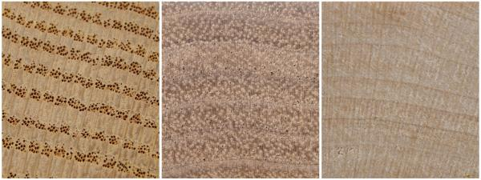
Image of ring-porousity: oak on the left, semi-ring porous walnut in the middle, hard maple on the right. You are looking at end-grain at 10X magnification.

Common wisdom is to use quarter-sawn white oak. I wouldn't do that. Sure, quarter-sawing brings out the beautiful radial rays, and it is the cut most likely to stay dimensionally flat in the presence of humidity changes. But oaks are easy to split along growth rings. If I were using oak, I would use a piece that was perfectly flat-sawn, meaning that the rings run almost flat when looked at on the end-grain.

Some woods have grain that is rowed (interlock your fingers at acute angles). The grain reverses direction in every square millimeter. American elm is a good example of this. It was traditionally used as hubs for wagon wheels and chair seats, being impossible to split, and although not particularly dense, was difficult to wear away. It also ranks low on rot-resistance. Another common wood that is rowed is Live oak, and it is rot-resistant. A neighbor's goats girdled some live oaks, killing them. They are still standing, and that was 35 years ago. But nobody saws live oak, and it's not particularly pretty for an oak.

Slow-growth southern yellow pine is strong and dense, resistant to splitting, and quite rot-resistant. Slow-growth yellow pine is stronger than fast-growth oak. It also has an unfortunate tendency to weep pearls of pitch in the hot sun.

Plywood: certainly strong enough, and if you use pressure-treated, it is rot-resistant. But if you have a boat with an aluminum hull, you must put a barrier between the wood and the aluminum, or the copper compounds in the pressure-treating will create an electrochemical cell that will corrode the aluminum. A sheet of 1/16” polyethylene between wood and metal would serve.

Coatings:

So you think to yourself, well, I'll just seal it really well, and that will stop the wood from absorbing moisture and rotting.

I'm sorry, it doesn't work that way.

No clear coating is going to completely protect a piece of wood from moisture. Period. All coatings eventually allow the transmission of airborne moisture, even epoxies. The wood will absorb and lose the moisture over multiple cycles. As it absorbs the moisture (we're talking simple changes in humidity, even daily), wood expands. As it loses it, it shrinks. With each dimensional change, the coating cracks slightly, allowing more moisture transfer. No coating I know can keep up with the changes. None are 100% moisture barriers, none are flexible enough.

Below is a 1998 summary (with link) of a large study done by the Forest Products Laboratory in 1985. They tested 91 different coatings on wood (more than half were pigmented paints), for each ones ability to block the uptake of moisture by wood. Notice that only two, a dipped (twice) coat in melted paraffin, and a catalyzed, pigmented epoxy paint, approached 90+%. Neither is a look you want for your transom board. A later study showed that linseed oil actually had a negative rating after it was aged, meaning that it absorbed moisture.

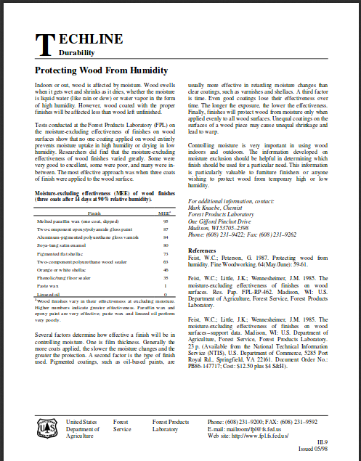

http://www.fpl.fs.fed.us/documnts/techline/protecting-wood-from-humidity.pdf

What would I do?

Choose a wood from the Most Resistant column, one that is available to you locally and that you like the look of. Choose one that is not so soft that it can be easily dented by the transom clamps, as cypress or red cedar would. I'm currently remaking inner and outer transom boards for a 1976 Alumacraft, based on the ghosts the original boards left on the aluminum stern, and on photographs of old original transoms. I chose wild cherry, because I have a stock of it (air-dried), it's pretty, sufficiently strong, works well, and has a good resistance to rot. I deliberately selected boards that have a curly grain, for resistance to splitting.

The finishing of it will be experimental, but based on 40+ years of experience with clear wood finishes. I'll spray them with three coats of automotive clear topcoat (Nason; it's a catalyzed polyurethane, with UV absorbers) on the outside, two brushed coats of liquid epoxy on the reverse faces, where wood touches aluminum, and the aluminum itself will get a coating of zinc chromate primer.

But mostly, when I'm done, I won't be leaving the boat out in the weather with the transom boards uncovered.

Clint Fountain

